Software Requirements Specification

for

Life Tree

Version <1.0>

Prepared by

Group Name: D2D

|  |  |  |
| --- | --- | --- |
| Chai Min Chun | 35657 | 35657@siswa.unimas.my |
| Choo Tingok Wei | 35769 | 35769@siswa.unimas.my |
| Lai Ted Liang | 36579 | 36579@siswa.unimas.my |
| Lim Ban Yong | 36709 | 36709@siswa.unimas.my |
| Willis Fung Shin Choi | 39324 | 39324@siswa.unimas.my |

|  |  |
| --- | --- |
| Instructor: | Madam Nurfauza Binti Jali |
| Course: | TMP 3413 Software Engineering Laboratory |
| Lab Section: | Teaching Lab 1 |
| Teaching Assistant: | Madam Nurfauza Binti Jali |

|  |  |
| --- | --- |
| Date: | <place the date of submission here> |

Contents

Revisions ii

1 Introduction 1

1.1 Document Purpose 1

1.2 Product Scope 1

1.3 Intended Audience and Document Overview 1

1.4 Definitions, Acronyms and Abbreviations 1

1.5 Document Conventions 1

1.6 References and Acknowledgments 2

2 Overall Description 3

2.1 Product Perspective 3

2.2 Product Functionality 3

2.3 Users and Characteristics 3

2.4 Operating Environment 3

2.5 Design and Implementation Constraints 4

2.6 User Documentation 4

2.7 Assumptions and Dependencies 4

3 Specific Requirements 5

3.1 External Interface Requirements 5

3.2 Functional Requirements 6

3.3 Behaviour Requirements 6

4 Other Non-functional Requirements 6

4.1 Performance Requirements 6

4.2 Safety and Security Requirements 7

4.3 Software Quality Attributes 7

5 Other Requirements 7

Appendix A – Data Dictionary 8

Appendix B - Group Log 9

Revisions

| Version | Primary Author(s) | Description of Version | Date Completed |
| --- | --- | --- | --- |
| 1.0 | Choo Ting Wei | Complete the requirement for the Life Tree Game project. | 00/00/00 |

# Introduction

This document provide a complete details of Software Requirement Specification (SRS) document for an Android game which name as Life Tree. This is an educational game that increase the awareness of pollution through interesting gameplay. In the following section of the SRS, we specify the purpose of this documents, project scope, intended audience, and included all sources that used to complete this document.

## Document Purpose

The purpose of this document is to give a detailed description of functional and non-functional requirement and functional requirement associated with Life Tree (Version). Life Tree (Version) SRS will act as the mainstay for any other document to be developed for this project in the future. Furthermore, it will serve as the guideline for the future software verification and testing by stating the behaviour requirement of the system in the form of a Use Case Diagram and Sequence Diagram.

## Product Scope

Life Tree shall be an Android based game which will allow user to play suing Android-powered smartphone / tablets version 4.0 and above. The game optimized for screen resolution of 800 x 480. The game user interface includes shop to buy items, setting scene, world / level selection screen, gameplay scene, pause scene, game complete scene, game over scene and tutorial scene. Apart from the scene, the game shall allow user to buy items, select level, adjust game setting, pause game function, and tutorial function for user.

Life Tree will be of the most benefit to teenagers and children. This game can educate the young generation about the consequences of pollution during the gameplay. Furthermore, the game shall has an easy to use interface and tutorials which can help user to more understand and attracted to the game. On the other hand, Life Tree can also use as a teaching material for students.

## Intended Audience and Document Overview

This SRS document is produce after the mutual agreement between development team and client through interviews to bind a contract. The details of SRS document should read and approved by both parties.

Section 2. This section of the SRS document will produces a full description of the product by specifying the product perspective, high level functionality of product and also general requirement of the product.

Section 3. This section of SRS describes the more specific requirement of the software. Use case diagram and state diagrams are use to describe the External Interfaces, Functional Requirement, and Behavior Requirements.

Section 4. This section of SRS explains non-functional requirements and focuses on software attributes such as maintainability, security, performance, reliability, usability and others.

## Definitions, Acronyms and Abbreviations

SFX - sound effect

## Document Conventions

**1.5.1 Document Conventions**

Several formatting conventions have been followed throughout the entire document:

1. Section titles are 18pt Arial font.
2. Subsection titles are 14pt Arial font.
3. Any further subsection breakdown is 12pt Arial font.
4. All text contained in this document is 11pt Arial font.
5. All sections and subsection are numbered using the X.X.X… format, where X represents numbers.
6. **Introduces terms are in bolded Times New Roman italics.**
7. Any further repetition of these terms is in Times New Roman italics.

**1.5.2 Naming Conventions**

TO DO: Describe any standards or typographical conventions that were followed when writing this SRS, such as fonts or highlighting that have special significance. Sometimes, it is useful to divide this section to several sections, e.g., Formatting Conventions, Naming Conventions, etc.>

## References and Acknowledgments

<List any other documents or Web addresses to which this SRS refers. These may include user interface style guides, contracts, standards, system requirements specifications, use case documents, or a vision and scope document.

TO DO: Use the standard IEEE citation guide for this section. An example citation guide is posted for you on the website.>

# Overall Description

## Product Perspective

Life Tree is a Windows phone’s game built on XNA games engine which founded by Althen and his teammates to join windows Imagine Cup. After the competition, the game passed to us for conversion and extension. After reverse reengineering the windows version Life Tree, the game is converted to Android platform and using AndEngine game engine due to previous game engine is incompatible with Android platform.

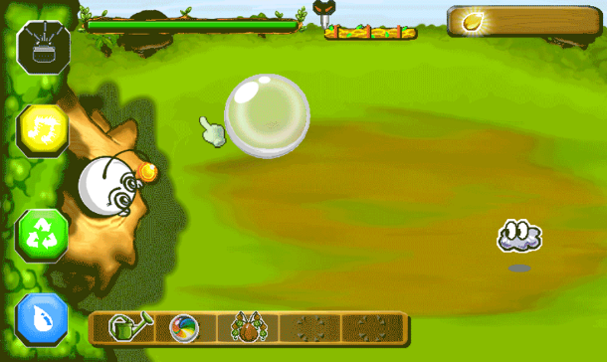

**Figure 1**: Life Tree gameplay scene

## Product Functionality

Functionality of Life Tree:

* Swipe release orb to attack on gameplay scene
* Straight line projectile
* Bounce projectile
* Shop for users to buy items
* Pause function on gameplay scene
* Background music and SFX is supported
* Skills can combined to produce new skills
* Monster with combination of element can only be killed by mix of orb
* User will get score once monster get killed

command

item

item

item

result

In_gameplay currency

Player

Shop

## Users and Characteristics

There will be only one user type playing the game. The user known as Player. No special knowledge or skills shall be assumed on the user.

The Player shall comfortable with Android smartphones / tablets and has no difficulties on English as the game shall operate in English language.

## Operating Environment

The Life Tree shall able to execute on Android-powered smartphone / tablet. The Android version should be version 4.0 and above. The optimize screen resolution is 800 x 480. No network connection is needed during the gameplay.

## Design and Implementation Constraints

After the requirement analysis process the following constraints were identified:

* Life Tree is built on Android platform using Java Programming language, therefore the project must be implement on Java programming language.
* Life Tree is a standalone application.
* Life Tree does not support multi-touch screen
* Life Tree only available for Android Operating System with version 4.0 or higher
* Only one player are available at a time

## User Documentation

No user documentation is available for the game currently. The in-game tutorials feature shall implement inside the gameplay. The tutorials will guide the user step by step during the gameplay.

## Assumptions and Dependencies

List of assumed factors that could affect the requirement of the game product.

* The Android OS must be in place.
* The minimum Android version must appropriate.
* Screen resolution must be in 800 x 400 to achieve the best resolution.
* The smartphone / tablet hardware resources such as RAM and must be adequate for the game application.

# Specific Requirements

## External Interface Requirements

### User Interfaces

<Describe the logical characteristics of each interface between the software product and the users. This may include sample screen images, any GUI standards or product family style guides that are to be followed, screen layout constraints, standard buttons and functions (e.g., Cancel) that will appear on every screen, error message display standards, and so on. Define the software components for which a user interface is needed.

TO DO: The least you can do for this section is to describe in words the different User Interfaces and the different screens that will be available to the user. Those who will be able to provide optional Graphical User Interface screenshots, will be rewarded by extra marks.>

### Hardware Interfaces

* Minimum Requirements:
* Processor: Nvidia Tegra 3 (Quad-core 1.2 GHz Cortex-A9)
* RAM: 1GB
* Disk Space: 400MB free space
* Screen Size: 800 x 1280 pixels
* Recommended Requirements:
* Processor: Nvidia Tegra K1 (Dual-core 2.3 GHz Denver)
* RAM: 2GB
* Disk Space: 800MB free space
* Screen Size: 1536 x 2048 pixels

### Software Interfaces

Android version: v4.0

### Communications Interfaces

N.A. – LifeTree does not requires Internet Connection or any online feature.

## Functional Requirements

*< Functional requirements capture the intended behavior of the system. This behavior may be expressed as services, tasks or functions the system is required to perform. This section is the direct continuation of section 2.2 where you have specified the general functional requirements. Here, you should list in detail the different product functions with specific explanations regarding every function.*

*TO DO: Brake the functional requirements to several functional areas and divide this section into subsections accordingly. Provide a detailed list of all product operations related to these functional areas.*

## Behaviour Requirements

### Use Case View

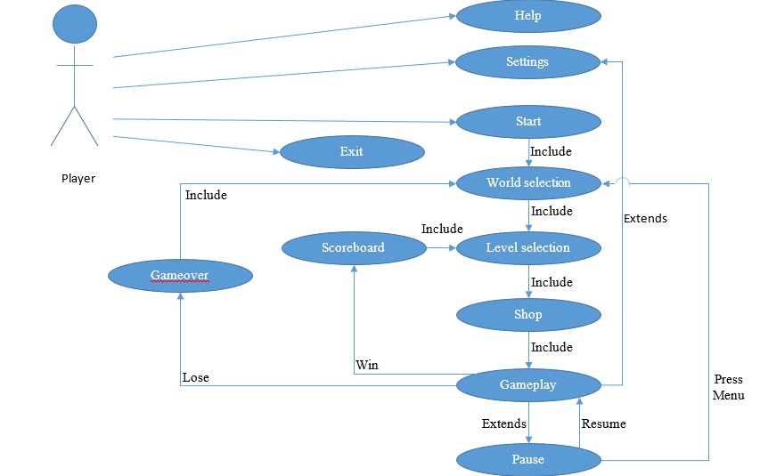

# Other Non-functional Requirements

## Performance Requirements

* + Game will not crash over 10 time average
  + The RAM usage of the game will not exceed 512MB
  + The game will not be lower than 60 frame per seconds.
  + During gameplay, the CPU utilization should not exceed 40%.
  + The application will not take more than 10 seconds to start.
  + Any item bought within the shop will not take more than 5 seconds.

## Safety and Security Requirements

* The application should be secure enough to prevent the corruption of codes from unauthorized users.
* The application shall minimise the number of permissions in order to mitigate risk of unintentionally misusing those permissions.
* The application shall be built by using Android SDK, instead of using native code with Android NDK. Applications built using Android NDK are complex, less portable and more likely to have memory corruption errors.

## Software Quality Attributes

### Availability

The application must be runnable when requested. The application should be runnable 90% of the time.

### Maintainability

All code shall be documented. Each function and parameters are given reasonable names to avoid confusion.

### Usability

The application shall be easy to understand so that users know how to play the game entirely on their first try.

### Flexibility

The application shall be runnable on any Android devices with version 4.0 and above.

# Other Requirements

<This section is **Optional.** Define any other requirements not covered elsewhere in the SRS. This might include database requirements, internationalization requirements, legal requirements, reuse objectives for the project, and so on. Add any new sections that are pertinent to the project.>

Appendix A – Data Dictionary

Entity : Main Activity

|  |  |  |  |
| --- | --- | --- | --- |
| Variable | Data Type | Access modifier | Description |
| cameraWidth | float | public | To store the recommended device width |
| cameraHeight | Float | public | To store the recommended device height |
| mCamera | Camera | public | In-game camera view for in-game camera use |

Entity : Game Manager

|  |  |  |  |
| --- | --- | --- | --- |
| Variable | Data Type | Access modifier | Description |
| mGameLevel | GameLevel | public |  |
| mGameLevelGoal | GameLevelGoal | public |  |

Entity : ResourceManager

|  |  |  |  |
| --- | --- | --- | --- |
| Variable | Data Type | Access modifier | Description |
| INSTANCE | Resource  Manager | public |  |
| cameraWidth | float | public |  |
| cameraHeight | float | public |  |
| cameraScaleFactorX | float | public |  |
| cameraScaleFactorY | float | public |  |
| clickSound | sound | public |  |

Entity : SFXManager

|  |  |  |  |
| --- | --- | --- | --- |
| Variable | Data Type | Access modifier | Description |
| mMusic | Music | private |  |
| levelSelectMusic | Music | private |  |
| mClick | Sound | private |  |

Entity : SceneManager

|  |  |  |  |
| --- | --- | --- | --- |
| Variable | Data Type | Access modifier | Description |
| mCurrentScene | ManagedScene | public |  |
| mNextScene | ManagedScene | private |  |
| mEngine | Engine | private |  |
| mNumFramesPassed | Ineteger | private |  |
| mLoadingScreeen  HandlerRegistered | boolean | private |  |

Appendix B - Group Log

<Please include here all the minutes from your group meetings, your group activities, and any other relevant information that will assist the Teaching Assistant to determine the effort put forth to produce this document>